REVIEW ARTICLE
Iran J Allergy Asthma Immunol
February 2019; 18(1):12-26.

The Stimulatory Effects of Medicinal Plants on β₂-adrenoceptors
of Tracheal Smooth Muscle

Farzaneh Shakeri¹, Vahideh Ghorani^{2,3}, Saeideh Saadat^{2,3}, Zahra Gholamnezhad^{2,3},
and Mohammad Hossein Boskabady^{2,3}

¹ Natural Products and Medicinal Plants Research Center, North Khorasan University of
Medical Sciences, Bojnurd, Iran
² Department of Physiology, School of Medicine, Mashhad University of Medical Sciences, Mashhad, Iran
³ Neurogenic Inflammation Research Center, Mashhad University of Medical Sciences, Mashhad, Iran

Received: 28 December 2017; Received in revised form: 13 May 2018; Accepted: 9 May 2018

ABSTRACT

Medicinal plants have been identified and used as primary sources in prevention and treatment of pulmonary diseases (mainly obstructive pulmonary diseases) from ancient times due to various pharmacological activities. In this review, the stimulatory effects of extracts, some fractions and constituents of medicinal plants on β₂-adrenoceptors which could be used as possible therapeutic agents in the future were reviewed.
Various databases including; Medline, PubMed, ScienceDirect, Scopus, and Google Scholar were searched using stimulatory effect, β₂-adrenoceptors, possible mechanism, tracheal smooth muscle (TSM), medicinal plants and their constituents as keywords from 1985 to 2017.
All studied plants including; Nigella sativa, Rosa damascena, Thymus vulgaris, Carum copticom, Carum carvi, Zataria multiflora, Crocus sativus, Cuminum cyminum, Liomnia acidissima, Portulaca oleraceae, Satureja hortensis, Ephedra sinica and Achillea millefolium showed relaxant effect on tracheal smooth muscle with a stimulatory effect on β₂-adrenoceptors mechanism.
The studied plants and their constituents could be of therapeutic value in clinical practice as a bronchodilatory drug by β₂-adrenoceptors stimulatory mechanism for treatment of obstructive pulmonary diseases.

Keywords: β₂-adrenoceptors; Medicinal plant; Possible mechanism; Stimulatory effect;
Tracheal smooth muscle

INTRODUCTION

Obstructive lung disease, including asthma,¹ bronchiectasis, bronchitis² and chronic obstructive
Corresponding Author: Mohammad Hossein Boskabady, MD, PhD;
Department of Physiology, School of Medicine, Mashhad
University of Medical Sciences, Mashhad, Iran.
pulmonary disease (COPD)³ have been specified by thickening of the airway walls, inﬁltration of inﬂammatory cells^{4,5}, enhanced smooth muscle mass⁶ and mucus secretion, epithelial shedding,^{7,8}
Tel: (+98 51) 3882 8565, Fax: (+98 51) 3882 8564, E-mail: boskabadymh@mums.ac.ir, boskabadymh@hotmail.com

hypertrophy and hyperplasia of airway smooth muscle, and inflammation of the airways.⁹ Common medications in asthma treatment include bronchodilators and anti-inflammatory drugs. Quick-relief medicines or bronchodilators include short-
acting inhaled β₂-agonists¹⁰ and anticholinergic¹¹, while long-term control medicines or anti-inflammatory drugs consist of antileukotrienes,¹² cromolyn sodium,¹³ inhaled corticosteroids,¹⁴ long-acting inhaled β₂-agonists,¹⁵ methylxanthines,¹⁶ and oral corticosteroids¹⁷.
Bronchodilators are a type of remedy used to treat asthma and COPD by dilation the bronchi and bronchioles, reducing resistance of the airways and enhancing airflow to the lungs.¹⁹ Bronchodilators may be endogenous that arise naturally within the body; nitric oxide (NO) is the endogenous neurotransmitter of bronchodilator nerves that produced in different parts of the body, including endothelial and epithelial cells, nerves, airway smooth muscle, and inflammatory cells.²⁰
The most important type of bronchodilator medications that applied for reliving treatment of obstructive pulmonary disease is β₂-agonists that stimulated β₂-adrenoceptors in tracheal smooth muscles (TSM).¹⁵ β adrenergic receptors are a member of the seven trans membrane family of receptors. Following β₂-adrenoceptor activation, second messenger cyclic adenosine monophosphate (cAMP) produced in the lung, which lead to decrease in calcium concentrations within cells, activate protein kinase A and myosin light-chain phosphatase, inactivate myosin light-chain kinase, open large conductance calcium-activated potassium channels and therefore produce smooth muscle relaxation and bronchodilation²¹ (Figure 1).
Herbal medicines are the major source of health care for the world’s population. Plants have a wide variety of secondary metabolites, such as flavonoids, alkaloids, trepenoids and coumarins, which have therapeutic properties. In the recent years, interest in drugs of plant origin has been progressively increased. In developing countries 80% of the population relies mainly on herbal medicine in primary medical problems.²²
The relaxant effect of different medicinal plants such as Rosmarinus ofﬁcinalis,²³ Hydrastis Canadensis,²⁴ Ferula assa-foetida,²⁵ Foeniculum vulgare,²⁶ Sarcoco ccasaligna,²⁷ Pimpinella anisum,²⁸ Achillea wilhelmsii ²⁹ and Syzygium cumini ³⁰ on tracheal smooth muscle has been shown.³¹ The possible mechanisms have been suggested for the relaxant effects of medicinal plants on tracheal smooth muscles, including stimulation of ß₂-adrenergic receptors,³² inhibition of histamine (H₁) receptors,³³ calcium channel-blocking effect,³⁴ potassium channel-opening effect,³⁵ inhibitory effect on muscarinic receptors ³⁴ and methylxanthine activity.³⁶
Different studies showed β₂-adrenoceptors stimulatory effect of various medicinal plants as the main mechanism of their tracheal smooth muscle relaxant effect. In this review, the stimulatory effects of the extracts, some fractions and constituents of the medicinal plants on β₂-adrenoceptors on tracheal smooth muscle were reviewed.

MATERIALS AND METHODS

Online literature searches were performed using Medline, PubMed, ScienceDirect, Scopus, and Google Scholar websites from 1985 to 2017 to identify studies about the effects of medicinal plants on β₂-adrenoceptors. The keywords used for searching were; medicinal plant, herbal medicine, β₂-adrenoceptors receptors, relaxant effect, tracheal smooth muscle, β₂-adrenoceptor competitive antagonists, propranolol, β₂-adrenoceptor agonists, isoprenaline and possible mechanism. A total of 55 articles were identified by two authors separately, the search results were checked and 41 eligible articles were included in this review. Abstracts or unpublished articles and non-English language articles were excluded from study.

Methods for Examining β₂-Adrenoceptor Stimulatory Effect of Medicinal Plants
The stimulatory effects of medicinal plant on β₂-adrenoceptors are usually examined by three general methods.
1) Examining the relaxant effects of medicinal plants, their fractions and constituents in non-incubated and incubated tracheal smooth muscle with a pharmacological β₂-competitive antagonist such as propranolol. In this method, reduced relaxant response in incubated tissues with β₂-competitive antagonist will indicate a possible β₂-adrenoceptor stimulatory effect. In some studies using this method, the effect of only one concentration of the extracts, fractions or constituents was examined. However, in other studies, the effect of the few concentrations were evaluated, which the effective concentration inducing 50% of maximum response (EC₅₀) was also determined (Figure 2).
2) Performing concentration-response curve to histamine or methacholine in the presence and absence of the extracts, fractions or constituents of medicinal plants in non-incubated and incubated tracheal smooth muscle with a pharmacological β₂-adrenoceptors antagonist such as propranolol. The increased maximum response and EC₅₀ as well as parallel shift in the concentration-response curve in the incubated tissues with pharmacological β₂-adrenoceptors antagonist will suggest a β₂-adrenoceptors stimulatory effect (Figure 3).
3) Performing concentration-response curve to a pharmacological β₂-adrenoceptors agonist such as isoprenaline in the present and the absence of the extracts of medicinal plants and their fractions or constituents. In this method, the shift of cumulative concentration-response curves to the left and reducing EC₅₀ isoprenaline in the presence of the extracts, fractions or constituents will show their stimulatory effect on β₂-adrenoceptors. In this method, repeating concentration-response curve to a β₂-agonist in the presence of a β₂-competitive antagonist will increase the clarity which will shift the agonist response curve to the right (Figure 4). This method is the most precise pharmacological method for evaluation of the stimulatory effect of an agent on β₂-adrenoceptors.

RESULTS

Effects of medicinal plants on β₂-adrenoceptors of tracheal smooth muscles by a competitive β₂-antagonist
The possible stimulatory effect of various extracts, fractions and constituents of several medicinal plants were examined by assessment of their relaxant effect on non-incubated and incubated tissues with a pharmacological β₂-adrenoceptors competitive antagonist. The relaxant effects of hydro-alcoholic extract of Achillea wilhelmsii were examined by their relaxant effects on pre-contracted tracheal chains of guinea pig by KCl or methacholine, under two different conditions, non-incubated and incubated tissues with propranolol. There was no significant difference in the relaxant effect between non-incubated and incubated tissues contracted by methacholine. The results showed a potent relaxant effect of the extract from Achillea wilhelmsii on tracheal chains which was not due to the stimulatory effect of β₂-adrenergic receptors.³⁵

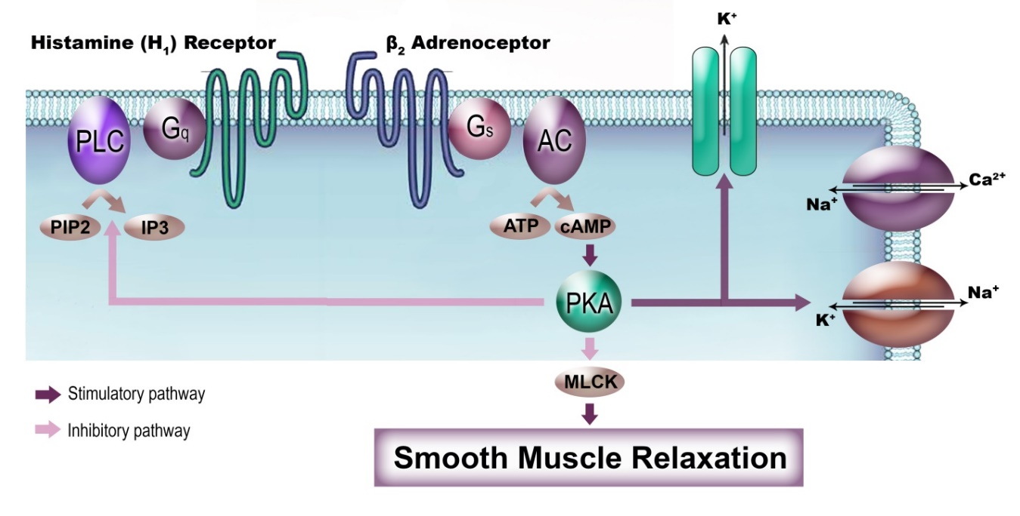
Figure 1. Schematic representation of the sites of phosphorylation for protein kinase A (PKA). The combined effect of phosphorylation at these sites leads to tracheal smooth muscle relaxation. MLCK=myosin light chain kinase; PLC=phospholipase C; IP₃=inositol trisphosphate; PIP₂=inositol bisphosphate; G=guanosine nucleotide binding protein; AC= adenylate cyclase.
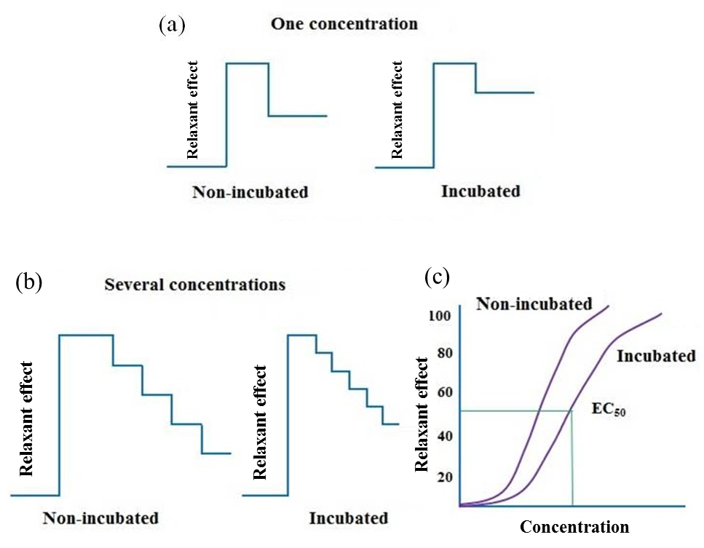

Figure 2. Evaluation of the stimulatory effect of medicinal plants on β₂-adrenoceptors by examining of the relaxant effect of an agent on tracheal smooth muscle in non-incubated and incubated tissues with a β₂-adrenoceptors competitive antagonist such as propranolol (a). A reduction in the relaxant effect in incubated tissue with β₂-adrenoceptors competitive antagonist will suggest a β₂-adrenoceptors stimulatory effect (a). In some studies, the effect of only one concentration of the agent is evaluated by this method (a). However, in other studies, the effect of few concentrations of the studied agent have been studied (b and c), and the concentration relaxant effect of the agent was performed (c) and EC₅₀ is calculated (c).

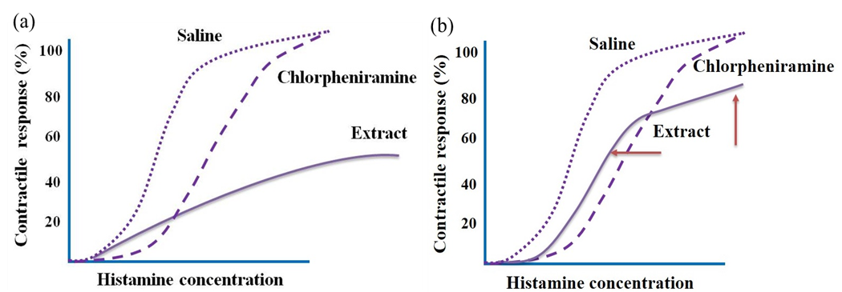

Figure 3. Examining the stimulatory effect of medicinal plants on β₂-adrenoceptors by performing concentration-response curve to histamine or methacholine in the presence and absence of the extracts, fractions or constituents of medicinal plants in non-incubated (a) and incubated (b) tracheal smooth muscles with a pharmacological β₂-adrenoceptors antagonist such as propranolol. The increased maximum response and EC₅₀ as well as parallel shift in the concentration-response curve in the incubated tissues with pharmacological β₂-adrenoceptors antagonist (b) will suggest a β₂-adrenoceptors stimulatory effect.
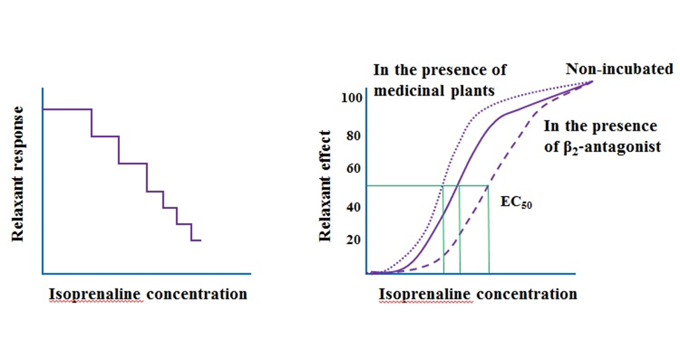
Figure 4. Examining the stimulatory effect of medicinal plants on β₂-adrenoceptors by performing concentration-response curve to a pharmacological β₂-adrenoceptors agonist such as isoprenaline in the present and the absence of the extracts of medicinal plants and their fractions or constituents. In this method, the shift of cumulative concentration-response curves to the left and reducing EC₅₀ agonist in the presence of the extracts, fractions or constituents will show their stimulatory effect on β₂-adrenoceptors. In addition, repeating concentration-response curve to a β₂-agonist in the presence of a β₂-competitive antagonist will increase the clarity, which will shift the agonist response curve to the right.

The relaxant effects of four fractions of essential oil from Carum copticum were examined on pre-contracted tracheal chains of guinea pig by KCl and methacholine in non-incubated tissues and incubated tissues with propranolol. The results suggested that the relaxant effect of essential oil from Carum copticum is mainly due to its fraction 2 (presumably carvacrol) and to a lesser extent fraction 3. The relaxant effects of all volumes of fractions were not significantly different between incubated and non-incubated tissues. As a result, their relaxant effects were not due to β-adrenergic stimulatory effect.³⁷
The bronchodilatory effects of three cumulative volumes of carvacrol (Sigma Chemical Ltd, UK), one of the constituents of Carum copticum, were examined by their relaxant effects on tracheal chains of guinea pigs pre-contracted by KCl and methacholine in two different conditions, non-incubated tissues and incubated tissues with propranolol. There was no significant difference in the relaxant effects of most volumes of carvacrol between non-incubated tissue and incubated tissue with propranolol. The results indicated that carvacrol has a potent relaxant effect on tracheal chains of guinea pigs, which was not due to β₂-adrenergic stimulatory effect.³⁸
The relaxant effects of four cumulative concentrations of aqueous-ethanolic extract of Crocus sativus were examined on guinea-pig tracheal chains. The tracheal chains have been pre-contracted using 60 mM KCl in non-incubated tissues and tissues incubated with 1 mM propranolol. The relaxant effects of most concentrations of extract in incubated tissues with propranolol were significantly lower than those of non-incubated tissues. The results suggested that the relaxant effect of this plant could be due to β₂-adrenoceptor stimulatory effect.³⁹
The relaxant effects of three cumulative concentrations of crocin (Sigma Chemical Co, St Louis, MO, USA), a constituent of Crocus sativus, were examined on pre-contracted tracheal smooth muscle by KCl in non-incubated or incubated with propranolol. There was no significant difference in the relaxant effects of crocin between non-incubated and incubated tissues with propranolol. The results also showed significant difference in EC₅₀ values of crocin, between non-incubated and incubated tissues with propranolol. The higher EC₅₀ value obtained in incubated tissues with propranolol may indicate a component of stimulatory effect of crocin on ß2-adrenoreceptors.⁴⁰
To evaluate the contribution of the β₂-adrenergic stimulatory effect of the macerated and aqueous extracts of Cuminum cyminum, the effects of four cumulative concentrations of these extracts on guinea pig tracheal chains were examined in the presence of propranolol. In propranolol-incubated tissues, the extracts of Cuminum cyminum did not show any significant relaxant effect on guinea pig tracheal chains. Only two last concentrations of macerated extracts showed non-significant relaxant effect on tracheal chains. The relaxant effects of most concentrations of both extracts in incubated tissues with propranolol were significantly lower than those of non-incubated tissues. The results showed a potent relaxant effect of Cuminum cyminum which may be due to a stimulatory effect of the plant on β₂-adrenoceptors.⁴¹
The relaxant effects of four cumulative concentrations of hydro-ethanolic extract of Curcuma longa were studied on tracheal smooth muscle pre-contracted by methacholine or KCl in non-incubated or incubated with propranolol. In tracheal smooth muscle incubated with propranolol, extract showed significant and concentration dependent relaxant effects. There was no significant difference in the relaxant effects of the Curcuma longa extract between non-incubated and incubated tissues with propranolol. The authors suggest that the relaxant effect of the extract was not due to its effect on β-adrenergic stimulatory effect.⁴²
The relaxant effects of the aqueous extract of Ferula assafoetida were examined on tracheal smooth muscle of guinea pig pre-contracted by methacholine in non-incubated and incubated with propranolol. There was no significant difference in the relaxant effects of the extract between non-incubated and incubated tissues with propranolol. The results showed a relaxant effect for the asafetida extract on tracheal smooth muscle, which was not due to β-adrenoceptors stimulation.²⁵
The relaxant effect of aqueous extract of Hypoxis hemerocallidea corm (African potato) was examined on spasmogen (histamine, carbachol and potassium)-provoked contractions of guinea-pig isolated tracheal smooth muscle preparations. The extract relaxed spasmogen-induced contractions in a concentration dependent manner. The relaxant effects of the extract were not altered by bath-applied propranolol (3.0 µg/mL), which markedly inhibited or completely abolished the relaxant effects of isoprenaline (0.1-5.0 µg/mL). It is unlikely that the aqueous extract of Hypoxis hemerocallidea stimulates the β₂-adrenoceptors.⁴³
The contribution of β₂-adrenergic stimulatory effect of macerated and soxhlet extracts of (pulp) of Liomnia acidissimain and their relaxant actions has been examined. The effects of these extracts were examined on pre-contracted tracheal chains by 60 mM KCl, 10 µM methacholine in non-incubated condition and propranolol (1 µM) incubated tissues contracted by 10 µM methacholine. The relaxant effects of all concentrations of the macerated and soxhlet extracts on propranolol incubated tissues were significantly higher than those of non-incubated tissues. Since the plant showed a potent relaxant effect which was completely blocked in incubated tissues with propranolol, the inhibitory effect of the plant on β-adrenoceptors is most probable with these results.⁴⁴
The relaxant effects of essential oil, aqueous and ethanol extracts of Pimpinella anisum were examined on pre-contracted tracheal smooth muscle of the guinea pig by methacholine in two different conditions, non-incubated and incubated tissues with propranolol. There was no significant difference in the relaxant effects of the extract between non-incubated and incubated tissues. The results showed that the relaxant effect of this plant was not due to the stimulatory effect of β₂-adrenergic receptors.²⁸
The relaxant effects of five cumulative concentrations of boiled and aqueous extracts of Portulaca oleracea were examined by their relaxant effects in tracheal chains of guinea pig pre-contracted with KCl and methacholine under two different conditions, non-incubated and incubated tissues with propranolol. The relaxant effects of most concentrations of both extracts from Portulaca oleracea obtained in incubated tissues were non-significantly greater than those of non-incubated tissues. These findings showed the absence of β-adrenergic stimulatory property of the plant extracts.³⁶
The relaxant effects of four cumulative concentrations of ethanolic extract and essential oils of Rosa damascena on tracheal chains of guinea pigs were examined by 60 mM KCl and 10 μM methacholine in two different conditions, non-incubated and incubated tissues with 1 µM propranolol. In incubated tissues with propranolol, ethanolic extract and essential oil of Rosa damascene did not show any significant relaxant effect compared to the effect of saline. The effects of most concentrations of ethanolic extract and essential oils in incubated tissues with propranolol were statistically lower than in those of non-incubated tissues. The results showed that the most probable mechanism responsible for the relaxant effect of Rosa damascena was a stimulatory effect on β₂-adrenoceptors.⁴⁵
The relaxant properties of six cumulative concentrations of hydro-ethanolic extract of Satureja hortensis on tracheal chains of guinea pigs were examined. Tracheal chains were contracted by 10 µM methacholine or 60 mM KCl and relaxant effect of the plant in two different conditions (non-incubated and incubated tissues with 1 µM propranolol) were evaluated. In incubated tissues with propranolol, Satureja hortensis did not show any significant relaxant effect compared to the effect of saline. The relaxant effects of most concentrations of extract in non-incubated tissues were statistically greater than those of incubated tissues. These findings suggested a probable β₂-adrenergic stimulatory property of the plant extract that may contribute to its relaxant effect on tracheal chins of guinea pig.⁴⁶
The relaxant effects of macerated and aqueous extracts of Thymus vulgaris were examined on pre-contracted tracheal chains of guinea-pig (60 mM KCl and 10 µM methacholine) in non-incubated tissues and incubated tissues with 1 µM propranolol. In incubated tissues with propranolol, the extracts of Thymus vulgaris did not show any significant relaxant effect compared to the effect of saline. The relaxant effects of most concentrations of both extracts in non-incubated tissues were statistically greater than those of incubated tissues with propranolol. The results suggested that the relaxant effect of this plant could be due to β₂-adrenoceptor stimulatory effect.⁴⁷
In Table 1, the stimulatory effect of the extracts and constituents of medicinal plants on β₂-adrenoceptors in tracheal smooth muscle by examining their relaxant effect on non-incubated and incubated tissues with a competitive β₂-antagonist are summarized.

Effects of Medicinal Plants on β₂-Adrenoceptors Incubated TSM with Propranolol on Concentration-Response Curve to Histamine and Methacholine
The stimulatory effect of three concentrations of Achillea millefolium aqueous-ethanolic extract on β₂-adrenoceptors in tracheal smooth muscle was tested by performing cumulative concentration-response curves of methacholine induced contraction in non-incubated and incubated tissues with propranolol. The EC₅₀ obtained in the presence of various concentrations of the extract were significantly in incubated tissues compared to non-incubated tissues. These results suggested the stimulatory effect of this plant on β₂-adrenoreceptors.⁴⁸
The stimulatory effect of essential oil and aqueous extract of Bunium persicum on β₂-adrenoceptors in tracheal smooth muscle was tested by performing cumulative concentration-response curves of histamine induced contraction in non-incubated and incubated tissues with propranolol. The results demonstrated
that the slope of histamine-response curves obtained in the presence of essential oil and aqueous extract,
and maximum response in the presence of aqueous extract as well as EC₅₀ obtained the presence of essential oil in incubated tissues were significantly higher than those of non-incubated tissues. These ﬁndings suggested a stimulatory effect of essential oil and aqueous extract of Bunium persicum on ß₂-adrenergic receptors.⁴⁹
To evaluate the contribution of the β₂-adrenergic stimulatory effects of the essential oil and ethanol extract of Carum copticum, the effects of these extracts were examined by performing the cumulative log concentration-response curves of histamine induced contraction on guinea pig tracheal chains in non-incubated and incubated tissues with propranolol. The results indicated that in the presence of essential oil, only in incubated tissues with propranolol histamine–response achieved the maximum response in the presence of ethanol extract which suggest a β₂-adrenergic stimulatory effect of essential oil and ethanol extract of this plant.⁵⁰
The effects of three concentrations of safranal (Sigma Chemical Co, St Louis, MO, USA), one constituent of Crocus sativus on tracheal smooth muscle of guinea pigs were examined by performing cumulative concentration-response curves of histamine induced contraction in two different conditions, non-incubated tissues and incubated tissues with propranolol. The maximum responses and the slope of histamine-response curves obtained in the presence of two higher concentrations of safranal and EC₅₀ obtained in the presence of all concentrations of safranal were significantly higher in incubated tissues compared to non-incubated tissues. These results suggested the stimulatory effect of safranal on β₂-adrenoreceptors.⁵¹

Table 1. The stimulatory effect of the extracts and constituents of medicinal plants on β₂-adrenoceptors in tracheal smooth muscle by examining their relaxant effect on non-incubated and incubated tissues with a competitive β₂-antagonist
Plant | Ext./Cons. | Conc. | Response | β₂-Stimulatory | Ref.
Achillea wilhelmsii | HEE | 2,4, 6 and 8 mg/mL | No difference between non-incubated and incubated tissues | − | ³⁵
Carum copticum | Four fractions of EO | 0.1, 0.2 and 0.4 mL  0.04, 0.08 and 0.12 mL | No difference between non-incubated and incubated tissues | − | ³⁷
 | Carvacrol | 0.02, 0.04, and 0.08 mL |  | − | ³⁸
Crocus sativus | HEE | 0.15, 0.3, 0.45, and 0.60 g% | Decreased relaxant effect in propranolol-incubated tissue | + | ³⁹
Crocus sativus | Crocin | 30, 60, and 120 μg/mL | No difference between non-incubated and incubated tissues, Increased EC50 value in propranolol-incubated tissue | + | ⁴⁰
Cuminum cyminum | AE  ME | 0.25, 0.5, 0.75 and 1.0 g% | Decreased relaxant effect of both extracts in propranolol-incubated tissue | + | ⁴¹
Curcuma longa | HEE | 6.25, 12.5, 25, 50 mg/mL | No difference between non-incubated and incubated tissues | − | ⁴²
Ferula asafoetida | AE | 2, 5 and 10 mg/mL | No difference between non-incubated and incubated tissues | − | ²⁵
Hypoxis hemerocallidea | AE | 25-400 mg/mL | No change in the relaxant effect of extract in presence of propranolol. | − | ⁴³
Liomnia acidissima | ME  Soxhlet extract | 0.5, 0.75, and 1.0 g% | Increased relaxant effect of both extracts in propranolol-incubated tissue | − | ⁴⁴
Pimpinella anisum | EO  AE  EE | 0.02 mL  0.6 mL  0.1 mL | No difference between non-incubated and incubated tissues | − | ²⁸
Portulaca oleracea | AE  BE | 0.25, 0.5, 0.75, 1.0 and 1.25 w/v | A non-significant difference between non-incubated and incubated tissues | − | ³⁶
Rosa damascene | EO | 0.25, 0.5, 0.75, and 1.0 vol.% | Decreased relaxant effect of both extracts in propranolol-incubated tissue | + | ⁴⁵
 | EE | 0.25, 0.5, 0.75, and 1.0 g% |  | +
Satureja hortensis | HEE | 0.15, 0.3, 0.45, 0.6, 0.75 and 0.9 g% | Decreased relaxant effect of extract in propranolol-incubated tissue | + | ⁴⁶
Thymus vulgaris | AE  ME | 0.25, 0.5, 0.75 and 1.0 g% | Decreased relaxant effect of extract in propranolol-incubated tissue | + | ⁴⁷
Relaxant effect examination on KCl or methacholine induced contraction in non-incubated and incubated tissues with propranolol. Abbreviations: Ext.: Extract, Cons.: Constituents, Conc.: Concentration AE.: Aqueous extract, BE: Boiled extract, EE: Ethanolic extract, ME.: Macerated extract, EO: Essential oil, HEE: Hydro-ethanolic extract, +: Stimulatory effect, −: non-stimulatory effect

The stimulatory effect of three concentrations of Crocus sativus hydro-ethanolic extract on β₂-adrenoceptors in tracheal smooth muscle was tested by performing cumulative concentration-response curves of histamine induced contraction in non-incubated and incubated tissues with propranolol. The results showed the maximum responses, the slope of histamine-response curves and EC₅₀ obtained in the presence of two higher concentrations of the extract were significantly lower than in non-incubated tissues compared to incubated tissues. These ﬁndings suggested probable β₂-adrenergic stimulatory effect of this extract.⁵²
The effect of macerated extract of Nigella sativa was tested by performing the cumulative log concentration-response curves of histamine induced contraction of isolated guinea pig tracheal chains with non-incubated and incubated tissues with propranolol. The results showed non-significant decrease in maximum response to histamine and the slope of the curves, between non-incubated and incubated tissues with propranolol which suggested probable β₂-adrenergic inhibitory effect of this extract.³³
Cumulative concentration-response curves of methacholine induced contraction in non-incubated and incubated tracheal smooth muscles with propranolol in the presence of three concentrations of Portulaca oleracea aqueous-ethanolic extract showed no significant difference in the maximum response, EC₅₀ and the slope of methacholine-response curves between in non-incubated and incubated tissues. These results showed the absence of stimulatory effect of this plant on β₂-adrenoreceptors.⁵³
Cumulative concentration-response curves of histamine induced contraction in non-incubated and incubated tissues with propranolol in the presence of three concentrations of Zataria multiflora hydro-ethanolic extract were also performed. The results showed that the values of CR-1 obtained in the presence of two lower concentrations of the extract were significantly higher than in non-incubated tissues compared to incubated tissues which suggested a stimulatory effect of the plant on β₂-adrenergic receptors.^{54,55}
The effect of Zataria multiflora hydro-ethanolic extract was tested by performing the cumulative log concentration-response curves of methacholine induced contraction of isolated guinea pig tracheal smooth muscle with non-incubated and incubated tissues with propranolol. The maximum response obtained in the presence of all concentrations of the extract, and the slope of methacholine-response curves in the presence of two higher concentrations of the extract as well as EC₅₀ obtained in the presence of high concentration extract in incubated tissues were significantly higher than non-incubated tissues. These ﬁndings suggested a stimulatory effect of this plant on ß₂-adrenergic receptors.⁵⁶
The effects of three concentrations of carvacrol (Sigma Chemical Ltd UK), one constituent of Zataria multiflora on tracheal smooth muscle of guinea pigs were examined by performing cumulative concentration-response curves of methacholine induced contraction in non-incubated and incubated tissues with propranolol. The results showed that the maximum responses and the values of CR-1 obtained in the presence of all concentrations of carvacrol and EC₅₀ obtained in the presence of two higher concentrations of carvacrol were significantly higher in incubated tissues compared to non-incubated tissues. These ﬁndings suggested a probable β₂-adrenergic stimulatory effect of carvacrol.⁵⁷
The stimulatory effect of the extracts and constituents of medicinal plants on β₂-adrenoceptors in tracheal smooth muscle by performing concentration-response curve to histamine and methacholine in non-incubated and incubated tissues with propranolol are summarized in Table 2.

Effects of Medicinal Plants on β₂-Adrenoceptors Using Concentration-Response Curves to a β₂-Adrenergic Agonist
As mentioned, the stimulation of β₂-adrenergic receptors is one of the major mechanisms involving in the relaxant effect of medicinal plants on tracheal smooth muscle⁵⁸. A well-known method for evaluation of the plants stimulatory effects on β₂-adrenoceptors in airway smooth muscles is performing the concentration-response curves to β₂-adrenoceptor agonist such as isoprenaline in the presence or absence of medicinal plants, which is more scientific method for this purpose. Leftward shift of β₂-agonist concentration-response curve indicates a stimulatory effect of the plant on β₂-adrenoceptors. Several studies were used this method to evaluated stimulatory effects of medicinal plants on β₂-adrenergic receptors.
The possible mechanism of the relaxant effect of three concentrations of Achillea millefolium hydro-ethanolic extract on tracheal smooth muscles was determined by performing concentration-response curves to isoprenaline in methacholine-contracted tracheal smooth muscle in the presence of the extract, propranolol and saline. Two high concentrations of extract led to leftward shifts in isoprenaline curves and also reduction of EC₅₀ isoprenaline compared to saline while the isoprenaline curve showed a clear rightward shift in the presence of propranolol.

Table 2. The stimulatory effect of the extracts and constituents of medicinal plants on β₂-adrenoceptors in tracheal smooth muscle by performing concentration-response curve to histamine and methacholine in non-incubated and incubated tissues with propranolol
Plant | Ext./Cons. | Conc. | Response | β₂-Stimulatory | Ref.
Achillea millefolium | HEE | 0.2, 0.4 and  0.8 mg/mL | Increased EC₅₀ value of methacholine in propranolol-incubated tissue | + | ⁴⁸
Bunium persicum | AE  EO | 36.9% W/W  1.5% V/V | Increased EC₅₀ value, maximum response and the slope of histamine-response curve in propranolol-incubated tissue | + | ⁴⁹
Carum copticum | EE  EO | 23% W/W  1.5% V/W | Increased maximum response to histamine in propranolol-incubated tissue | + | ⁵⁰
Crocus sativus | Safranal | 0.63, 1.25 and  2.5 μg/mL | Increased EC₅₀ value, maximum response and the slope of histamine-response curve in propranolol-incubated tissue | + | ⁵¹
 | HEE | 0.025, 0.05 and  0.1 g% | Increased EC₅₀ value, maximum response and the slope of histamine-response curve in propranolol-incubated tissue | + | ⁵²
Nigella sativa | ME | 18% W/W | Decreased maximum response and the slope of histamine-response curve in propranolol-incubated tissue | − | ³³
Portulaca oleracea | HEE | 0.25, 0.50 and  1.00 mg/mL | No significant difference between in non-incubated and incubated tissues | − | ⁵³
Zataria multiflora | HEE | 2.5, 5 and 10 μg/mL | Decreased the value of CR-1 in propranolol-incubated tissue | + | ^{54, 55}
 | HEE | 0.5, 1 and 2 μg/mL | Increased EC₅₀ value, maximum response and the slope of methacholine-response curve in propranolol-incubated tissue | + | ⁵⁶
 | Carvacrol | 0.1, 0.2  and 0.4 mg/mL | Increased EC₅₀ value, maximum response and the value of CR-1 of methacholine-response curve in propranolol-incubated tissue | + | ⁵⁷
Abbreviations: Ext: Extract, Cons.: Constituents, Conc.: Concentration AE: Aqueous extract, EE: Ethanolic extract, ME: Macerated extract, EO: Essential oil, HEE: Hydro-ethanolic extract, EC50: Effective concentration causing 50% of maximum response, CR-1: concentration ratio minus one, +: Stimulatory effect, −: non-stimulatory effect

Therefore, the extract of Achillea millefolium showed small stimulatory effect on β₂-adrenergic receptors.⁵⁹
In a study, the stimulatory effect of macerated, aqueous and ethanolic extract, and essential oil of Carum copticum on β₂-adrenoreceptors of guinea pig tracheal smooth muscle was also examined. Performing of concentration-response curves of isoprenaline in the presence of extracts, essential oil, saline and propranolol indicated that the only ethanol extract of Carum copticum led to leftward shifts in isoprenaline curves. Therefore, ethanolic extract of Carum copticum showed a clear stimulatory effect on β₂-adrenergic receptors.⁶⁰ In a clinical study, the bronchodilatory effect of 0.125 and 0.25 mL/kg of 10 g% boiled extract of Carum copticum in airways of asthmatic patients was also shown.⁶¹ According to previous studies, various mechanisms for the bronchodilator effect of this plant have been proposed. However, the possible mechanism for the bronchodilatory effect of this plant on the small airways is stimulation of β₂-adrenoreceptors due to the high density of these receptors in small airways.⁶²
The stimulatory effect of hydro-ethanolic extract of Crocus sativus and one of its constituents, safranal, on β₂-adrenoceptors in tracheal smooth muscle was tested by performing cumulative concentration-response curves of isoprenaline-induced relaxation on pre-contracted smooth muscle. The results demonstrated leftward shifts in isoprenaline curves in the presence of the extract, safranal but rightward shift of isoprenaline curve in the presence of propranolol. In addition, as decrease in EC₅₀ isoprenaline was also observed in the presence of Crocus sativus extract and safranal. These results pharmacologically indicate the stimulatory effect for the plant extract and safranal on β₂-adrenoreceptors.⁶³
Ephedrine is one of the constituents of Ephedra sinica (also known as Chinese ephedra). The relaxant effect of ephedrine on the tracheal smooth muscles of guinea pigs through β₂-adrenoreceptors stimulating mechanism was investigated. For this purpose, concentration-response curves for isoprenaline in tracheal tissue were drawn. These findings demonstrated a rightward shift of the concentration-response curves for isoprenaline in the presence of the ephedrine, which indicates the small inhibitory effect of ephedrine on β₂-adrenoceptors and suggests that other mechanisms may involve in the relaxant effect of ephedrine.⁶⁴
Similarity to investigate the possible mechanism of the relaxant effect of optical isomers of ephedrine in guinea pig tracheal smooth muscle, the l-ephedrine concentration-response curve in the presence of propranolol was performed. The results showed a rightward shift of the l-ephedrine concentration-response curve for propranolol. Therefore, these findings may suggest that l-ephedrine-induced relaxation of the guinea pig trachea is mediated by β₂-adrenoceptors.⁶⁵
Boskabady et al demonstrated the stimulatory effect of the aqueous and macerated extracts of Nigella sativa on β₂-adrenoreceptors tracheal smooth muscle of guinea-pigs. Concentration-response curves to isoprenaline in tracheal smooth muscle indicated leftward shifts in the presence of the both extracts. The results showed a clear stimulatory effect on β₂-adrenoreceptors for the aqueous extract of this plant while macerated extracts of Nigella sativa indicate a possible stimulatory effect on β₂-adrenoreceptors.⁶⁶
Another study was shown that hydro-ethanolic extract of Portulaca oleracea affects beta-adrenoceptors of guinea pig tracheal smooth muscle. For this purpose, concentration-response curve to isoprenaline was obtained in the presence of three concentrations of hydro-ethanolic extract, propranolol, and saline. The results indicated leftward shift of concentration-response curves to isoprenaline in the presence of the extract, while the curve of propranolol showed a rightward shift compared to isoprenaline curves. EC₅₀ isopernaline in the presence of the extract was also decreased. These results showed a stimulatory effect of this plant on β₂-adrenoceptors.⁶⁷
Zataria multiflora Boiss and its constituent, carvacrol (Fluka, Italy, Catalogue no. C4915, purity 75%), also showed the stimulatory effects on β₂-adrenoceptors of the guinea pig trachea. To examine the stimulatory effect of β₂-adrenoceptors, cumulative log concentration-response curves to isoprenaline in the presence of extracts, carvacrol and propranolol were performed. The results showed the leftward shifts in isoprenaline curves in the presence of the hydro-ethanolic extract (0.5, 1, and 2μg/mL) and carvacrol as well as decrease of EC₅₀ isoprenaline value while, curve of propranolol showed a rightward shift. Therefore, the results suggest the stimulatory effect for the plant extract and carvacrol on β₂-adrenoreceptors.⁶⁸ Moreover, the effect of three concentrations (0.05, 0.1 and 0.2 mg/mL) of Zataria multiflora hydro-ethanolic extract on β₂-adrenoceptors in tracheal smooth muscles were also evaluated by similar method as described above. The results showed the stimulatory effect of this plant on β₂-adrenoceptors of the tracheal smooth muscles of guinea pigs.⁶¹ In another study, the stimulatory effect of Zataria multiflora on β₂-adrenergic receptors on guinea pig tracheal smooth muscle was also suggested.⁵⁶
The stimulatory effect of the extracts and constituents of medicinal plants on β₂-adrenoceptors in tracheal smooth muscle by performing cumulative log concentration-response curves to isoprenaline are summarized in Table 3.

Table 3. The stimulatory effect of the extracts and constituents of medicinal plants on β₂-adrenoceptors in tracheal smooth muscle by performing cumulative log concentration-response curves to isoprenaline
Plant | Ext./Cons. | Conc. | Response | β₂-Stimulatory | Ref.
Achillea millefolium | HEE | 0.2, 0.4, and 0.8 mg/mL | Leftward shifts in Isop. curves, Reduction of EC₅₀ | + | ⁵⁹
Carum copticum | AE, EE, ME, EO | AE 27% W/W  EE 23% W/W  ME 25% W/W  EO 1.5% W/V | Leftward shifts in Isop. curves | + | ³²
Crocus sativus | HEE  Safranal | - and 0.2 g%  1.25 and 2.5 µg | Leftward shifts in Isop. curves, Reduction of EC₅₀ | + | ⁶³
Ephedra sinica | Ephedrine | 100 μmol/l | Rightward shifts in Isop. curves | ± | ⁶⁴
Nigella sativa | AE, ME | 10% W/W | Leftward shifts in Isop. curves | + | ⁶⁶
Portulaca oleracea | HEE | 0.06, 0.12 and  0.25 mg/mL | Leftward shifts in Isop. curves, Reduction of EC₅₀ | + | ⁶⁷
Zataria multiflora | HEE  Carvacrol | 0.5, 1, and 2 μg/mL  0.1, 0.2, and 0.4 μg/mL | Leftward shifts in Isop. curves, Reduction of EC₅₀ | + | ⁶⁸
 | HEE | 0.05, 0.1 and  0.2 mg/mL | Leftward shifts in Isop. curves, Reduction of EC₅₀ | + | ⁶⁹
Cumulative log concentration-response curve (CLCRC) of Isop. of guinea pig tracheal chain was performed in presence of the various extracts of medicinal plants and constituents, propranolol and saline. Abbreviations: Ext.: Extract, Cons.: Constituents, Conc.: Concentration, AE: Aqueous extract, EE: Ethanolic extract, ME: Macerated extract, EO: Essential oil, HEE: Hydro-ethanolic extract, Isop: Isoprenaline, EC₅₀: Effective concentration causing 50% of maximum response. +: Stimulatory effect, ±: Small stimulatory effect.

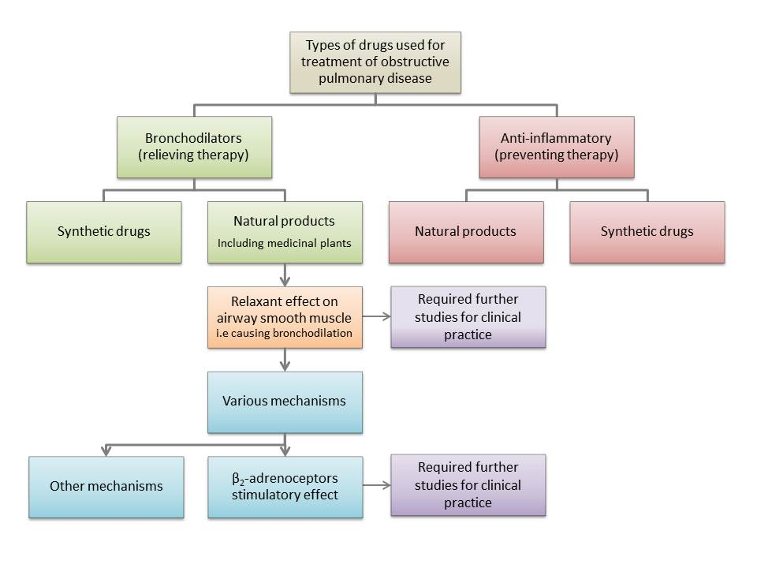
Figure 5. Current knowledge about the effect of natural products (mainly medicinal plants and their constituents) on respiratory disease and suggested further studies.

CONCLUSION

Beta₂-adrenoceptors stimulatory drugs are one of the most important bronchodilatory drugs which used to relieve bronchoconstriction in pulmonary obstructive disease mainly asthma. The knowledge regarding the use of medicinal plants in obstructive pulmonary disease has been poor yet. Therefore, the stimulatory effect of medicinal plants on β₂-adrenoceptors which could be pointed to use of medicinal plant with this property as bronchodilatory drugs were reviewed. This review showed the relaxant effect of medicinal plants, their fractions and constituents on tracheal smooth muscle, which indicated their bronchodilatory effect by β₂-adrenoceptors stimulatory mechanism. As a result, the tracheal relaxant effect of Achillea millefolium, Carum copticom, Carumcarvi, Crocus sativus, Cuminum cyminum, Ephedra sinica, Liomnia acidissima, Nigella sativa, Portulaca oleraceae, Rosa damascena, Satureja hortensis, Thymus vulgaris, and Zataria multiflora, some of their fractions and constituents may be mediated via β₂-adrenoceptors stimulation.
Therefore, the extracts and essential oil of the above medicinal plant, their fractions and constituents would be of therapeutic potential on obstructive pulmonary diseases as bronchodilator or relieving drugs by this mechanism. However, further clinical and experimental studies were required to demonstrate the clinical applications of the mentioned medicinal plants, their fractions and constituents on pulmonary obstructive diseases such as asthma more clearly.

ACKNOWLEDGEMENTS

This study was supported by Research Council of Mashhad University of Medical Sciences.

REFERENCES

1. Ghosh S, Hoselton SA, Schuh JM. Allergic Inflammation in Aspergillus fumigatus-Induced Fungal Asthma. Curr Allergy Asthma Rep 2015; 15(10):1-11.
2. Wang KCW, Le Cras TD, Larcombe AN, Zosky GR, Elliot JG, James AL, et al. Independent and combined effects of airway remodelling and allergy on airway responsiveness. Clin Sci 2018; 132(3):327-38.
3. Lindell DM, Berlin AA, Schaller MA, Lukacs NW. B cell antigen presentation promotes Th₂ responses and immunopathology during chronic allergic lung disease. PLoS One 2008; 3(9):1-14.
4. Ghosh S, Hoselton SA, Asbach SV, Steffan BN, Wanjara SB, Dorsam GP, et al. B lymphocytes regulate airway granulocytic inflammation and cytokine production in a murine model of fungal allergic asthma. Cell Mol Immunol 2015; 12(2):202-12.
5. Ghosh S, Hoselton SA, Dorsam GP, Schuh JM. Eosinophils in fungus-associated allergic pulmonary disease. Front Pharmacol 2013; 4(8):1-18.
6. Elaidy SM, Essawy SS, Hussain MA, El-Kherbetawy
MK, Hamed ER. Modulation of the IL-23/IL-17 axis
by fenofibrate ameliorates the ovalbumin/lipopolysaccharide-induced airway inflammation and bronchial asthma in rats. Naunyn Schmiedebergs Arch Pharmacol 2018; 391(3):309-21.
7. Kim YH, Choi YJ, Lee EJ, Kang MK, Park SH, Kim DY, et al. Novel glutathione-containing dry-yeast extracts inhibit eosinophilia and mucus overproduction in a murine model of asthma. Nutr Res Pract 2017; 11(6):461-69.
8. Ghosh S, Hoselton SA, Schuh JM. μ-chain-deficient mice possess B-1 cells and produce IgG and IgE, but not IgA, following systemic sensitization and inhalational challenge in a fungal asthma model. J Immunol 2012; 189(3):1322-9.
9. Vignola AM, Kips J, Bousquet J. Tissue remodeling as a feature of persistent asthma. J Allergy Clin Immunol 2000; 105(6):1041-53.
10. Yates D, Kharitonov S, Barnes P. Effect of short-and long-acting inhaled beta2-agonists on exhaled nitric oxide in asthmatic patients. Eur Res J 1997; 10(7):1483-8.
11. Gross NJ. Anticholinergic agents in asthma and COPD. Eur J Pharmacol 2006; 533(1):36-9.
12. Dahlén S-E. Treatment of asthma with antileukotrienes: first line or last resort therapy? Eur J Pharmacol 2006; 533(1):40-56.
13. Breslin FJ, McFadden Jr E, Ingram Jr R. The effects of cromolyn sodium on the airway response to hyperpnea and cold air in asthma 1–3. Am Rev Respir Dis 1980; 122(1):11-6.
14. Guilbert TW, Morgan WJ, Zeiger RS, Mauger DT, Boehmer SJ, Szefler SJ, et al. Long-term inhaled corticosteroids in preschool children at high risk for asthma. New Engl J Med 2006; 354(19):1985-97.
15. Bisgaard H. Long‐acting β₂‐agonists in management of childhood asthma: A critical review of the literature. Pediatr Pulmonol 2000; 29(3):221-34.
16. Sankar J, Lodha R, Kabra S. Doxofylline: The next generation methylxanthine. Indian J Pediatr 2008; 75(3):251-4.
17. Chaudhuri R, Livingston E, McMahon AD, Thomson L, Borland W, Thomson NC. Cigarette smoking impairs the therapeutic response to oral corticosteroids in chronic asthma. Am J Respir Crit Care Med 2003; 168(11):1308-11.
18. Long AA, editor Immunomodulators in the treatment of asthma. Allergy Asthma Proc; 2009: OceanSide Publications, Inc.
19. Donohue JF. Therapeutic responses in asthma and COPD: bronchodilators. CHEST J 2004;126(2 suppl 1):125S-37S.
20. Di Maria G, Spicuzza L, Mistretta A, Mazzarella G. Role of endogenous nitric oxide in asthma. Allergy 2000; 55(s61):31-5.
21. Johnson M. Beta2-adrenoceptors: mechanisms of action of beta₂-agonists. Paediatr Respir Rev 2001; 2(1):57-62.
22. Kumara N, editor Identification of strategies to improve research on medicinal plants used in Sri Lanka. WHO Symposium University of Ruhuna, Galle, Sri Lanka; 2001.
23. Aqel M. Relaxant effect of the volatile oil of Romarinus officinalis on tracheal smooth muscle. J Ethnopharmacol 1991; 33(1-2):57-62.
24. Abdel‐Haq H, Cometa MF, Palmery M, Leone MG, Silvestrini B, Saso L. Relaxant effects of Hydrastis canadensis L. and its major alkaloids on guinea pig isolated trachea. Basic Clin Pharmacol Toxicol 2000; 87(5):218-22.
25. Gholamnezhad Z, Byrami G, Boskabady MH, Iranshahi M. Possible mechanism (s) of the relaxant effect of asafoetida (Ferula assa-foetida) oleo-gum-resin extract on guinea-pig tracheal smooth muscle. Avicenna J Phytomed 2011; 2(1):10-6.
26. Boskabady M, Khatami A, Nazari A.. Relaxant effect of Foeniculum vulgare on isolated guinea pig tracheal chains. ‎Pharm Biol 2003; 41(3):211-5.
27. Ghayur MN, Gilani AH. Studies on cardio-suppressant, vasodilator and tracheal relaxant effects of Sarcococca saligna. Arch Pharm Res 2006; 29(11):990-7.
28. Boskabady M, Ramazani-Assari M. Relaxant effect of Pimpinella anisum on isolated guinea pig tracheal chains and its possible mechanism (s). J Ethnopharmacol 2001; 74(1):83-8.
29. Boskabady M, Eftekhar N, Kaveh M, Nemati A. Relaxant effects of Achillea wilhelmsi on guinea-pig tracheal chains. Pharmacologyonline 2009; 3:893–9.
30. Mahapatra P. Relaxant effects of Syzygium cumini leaves on guinea pig tracheal chains and its possible mechanism (s). Journal of Biomedical and Pharmaceutical Research 2012;1(02).
31. Shakeri F, Boskabady MH. A review of the relaxant effect of various medicinal plants on tracheal smooth muscle, their possible mechanism (s) and potency. J Ethnopharmacol 2015; 175:528-48.
32. Boskabady M, Moemeni A. Stimulatory effect of Carum copticum on β₂ adrenoceptors of isolated guinea pig tracheal chains. Med J Islam Repub Iran (MJIRI) 2000; 13(4):273-8.
33. Boskabady M, Sheiravi N. Inhibitory effect of Nigella sativa on histamine (H₁) receptors of isolated guinea pig tracheal chains. ‎Pharm Biol 2002; 40(8):596-602.
34. Boskabady M, Shahabi M. Bronchodilatory and anticholinergic effects of Nigella sativa on isolated guinea pig tracheal chains. Iran J Med Sci 1997; 22(3&4):133.
35. Boskabady MH, Eftekhar N, Kaveh M. Possible mechanism (s) of the relaxant effects of Achillea wilhelmsii on guinea-pig tracheal chains. Iran J Pharm Res 2013; 12(2):381-7.
36. Boskabady MH, Boroushaki M, Aslani MR. Relaxant effect of Portulaca oleraceae on guinea pig tracheal chains and its possible mechanism (s) of action. Med Hypotheses Res 2004; 1:139-47.
37. Boskabady M, Ramazani M, Tabei T. Relaxant effects of different fractions of essential oil from Carum copticum on guinea pig tracheal chains. Phytother Res 2003; 17(10):1145-9.
38. Boskabady M, Jandaghi P. Relaxant effects of carvacrol on guinea pig tracheal chains and its possible mechanisms. Pharmazie 2003; 58(9):661-3.
39. Boskabady Ma, Aslani M. Relaxant effect of Crocus sativus (saffron) on guinea‐pig tracheal chains and its possible mechanisms. ‎J Pharm Pharmacol 2006; 58(10):1385-90.
40. Saadat Aslani and M. Boskabady. The relaxant effect of crocin on rat tracheal smooth muscle and its possible mechanisms S, M. Yasavoli, Z. Gholamnezhad, M. R.. Iran J Pharm Res 2017.
41. Boskabady M, Kiani S, Azizi H. Relaxant effect of Cuminum cyminum on guinea pig tracheal chains and its possible mechanism (s). Indian J Pharmacol 2005; 37(2):111.
42. Emami B, Shakeri F, Ghorani V, Boskabady MH. Relaxant effect of Curcuma longa on rat tracheal smooth muscle and its possible mechanisms. Pharm Biol 2017; 55(1):2248-58.
43. Ojewole JA, Olayiwola G, Nyinawumuntu A. Bronchorelaxant property of African potato'(Hypoxis hemerocallidea corm) aqueous extract in vitro. J Smooth Muscle Res 2009; 45(5):241-8.
44. Mahapatra pkadp. Relaxant effects of Limonia acidissima linn (pulp) on guinea pig tracheal chains and its possible mechanism (s). Int J Pharm Pharm Sci 2014;6:257-63.
45. Boskabady MH, Kiani S, Rakhshandah H. Relaxant effects of Rosa damascena on guinea pig tracheal chains and its possible mechanism (s). J Ethnopharmacol 2006; 106(3):377-82.
46. Boskabady MH, Aslani M, Mansuri F, Amery S. Relaxant effect of Satureja hortensis on guinea pig tracheal chains and its possible mechanism (s). DARU 2007;15(4):199-204.
47. Boskabady MH, Aslani M, Kiani S. Relaxant effect of Thymus vulgaris on guinea‐pig tracheal chains and its possible mechanism (s). Phytother Res 2006; 20(1):28-33.
48. Feizpour A, Boskabady MH, Byrami G, Golamnezhad Z, Shafei MN. The effect of hydro-ethanolic extract of Achillea millefolium on muscarinic receptors of guinea pig tracheal smooth muscle. Indian J Pharmacol 2013; 45(1):13-7.
49. Boskabady MH, Moghaddas A. Antihistaminic effect of Bunium persicum on Guinea Pig tracheal chains. Iran Biomed J 2004; 8(3):149-55.
50. Boskabady MH, Shaikhi J. Inhibitory effect of Carum copticum on histamine (H₁) receptors of isolated guinea-pig tracheal chains. J Ethnopharmacol 2000; 69(3):217-27.
51. Boskabady MH, Rahbardar MG, Jafari Z. The effect of safranal on histamine (H₁) receptors of guinea pig tracheal chains. Fitoterapia 2011; 82(2):162-7.
52. Boskabady MH, Rahbardar MG, Nemati H, Esmaeilzadeh M. Inhibitory effect of Crocus sativus (saffron) on histamine (H₁) receptors of guinea pig tracheal chains. Pharmazie 2010; 65(4):300-5.
53. Hashemzehi M, Khazdair M, Kiyanmehr M, Askari V, Boskabady M. Portulaca olerace affects muscarinic receptors of guinea pig tracheal smooth muscle. ‎Indian J Pharm Sci 2016;78(3):388-94.
54. Boskabady MH, Tabanfar H. Effect of Zataria multiflora Bois L. on histamine (H 1) receptor of guinea pig tracheal chains. Indian J Exp Biol 2011; 49(9):679-83.
55. Boskabady MH, Tabanfar H, Gholamnezhad Z, Sadeghnia HR. Inhibitory effect of Zataria multiflora Boiss and carvacrol on histamine (H1) receptors of guinea‐pig tracheal chains. Fundam Clin Pharmacol 2012; 26(5):609-20.
56. Boskabady MH, Jafari Z, Pouraboli I, Babazade B, Rahbardar MG. Anti-cholinergic effect of Zataria multiflora Boiss on guinea pig tracheal chains. ‎Nat Prod Res 2012;26(16):1523-8.
57. Boskabady M, Jafari Z, Pouraboli I. Phytother Res 2011; 25(4):530-5.
58. Linden A, Bergendal A, Ullman A, Skoogh B-E, Löfdahl CG. Salmeterol, formoterol, and salbutamol in the isolated guinea pig trachea: differences in maximum relaxant effect and potency but not in functional antagonism. Thorax 1993; 48(5):547-53.
59. Koushyar H, Koushyar M, Byrami G, Feizpour A, Golamnezhad Z, Boskabady MH. The effect of hydroethanol extract of Achillea millefolium on β-adrenoceptors of guinea pig tracheal smooth muscle. ‎Indian J Pharm Sci 2013; 75(4):400-5.
60. Boskabady M, Moemeni A. Stimulatory effect of Carum copticum on β₂ adrenoceptors of isolated guinea pig tracheal chains. Med J Islam Repub Iran 2000; 13(4):273-8.
61. Boskabady MH, Alizadeh M, Jahanbin B. Bronchodilatory effect of Carum copticum in airways of asthmatic patients. Therapie 2007; 62(1):23-9.
62. Pendry YD. Neuronal control of airways smooth muscle. ‎Pharmacol Ther 1993; 57(2-3):171-202.
63. Nemati H, Boskabady MH, Vostakolaei HA. Stimulatory effect of Crocus sativus (saffron) on β 2-adrenoceptors of guinea pig tracheal chains. Phytomedicine 2008; 15(12):1038-45.
64. Waldeck B, Widmark E. The interaction of ephedrine with β‐adrenoceptors in tracheal, cardiac and skeletal muscles. Clin Exp Pharmacol Physiol 1985; 12(4):439-42.
65. Koike K, Kawasuji T, Saito H, Matsumoto M, Yasuda N, Niizawa Si, et al. Relaxant responses by optical isomers of ephedrine and methylephedrine in guinea pig tracheal smooth muscle. Pharmacology 1996; 53(5):289-95.
66. Boskabady MH, Kiani S, Jandaghi P. Stimulatory effect of Nigella sativa on β₂-adrenoceptors of guinea pig tracheal chains. Med J Islam Repub Iran 2004; 18(2):153-8.
67. Boskabady MH, Hashemzehi M, Khazdair MR, Askari VR. Hydro-ethanolic Extract of Portulaca oleracea Affects Beta-adrenoceptors of Guinea Pig Tracheal Smooth Muscle. Iran J Pharm Res 2016; 15(4):867-74.
68. Boskabady MH, Kaveh M, Eftekhar N, Nemati A. Zataria multiflora Boiss and carvacrol affect β2-adrenoceptors of guinea pig trachea. Evid Based Complement Alternat Med 2011; 2011:857124.
69. Boskabady MH, Eftekhar N, Nemati A. The effect of Zataria multiflora boiss on ß2-adrenoceptors of guinea pig tracheal cahins. Pharmacologyonline 2009; 1:749-56.

